TARIQ NAWAZ

BS(Food Science & Technology)

(Agricultural Sciences)

Career Objectives:

To contribute in the growth and vision of a dynamic institute while utilizing my potential for achieving excellence and enhancing my skills. I want to promote my culture as well and adapt myself to the new environment.

Academic Qualification:

|  |  |  |  |  |
| --- | --- | --- | --- | --- |
| Degree | Institute/Board | Passing Year | Obtained Marks/  CGPA | Total Marks/  CGPA |
| BS(Food Science) | University of Haripur | Continue | 3.75 | 4.00 |
| F.Sc  (Pre-Eng ) | BISE Abbottabad | 2017 | 715 | 1100 |
| Matriculation  Science | BISE Mardan | 2015 | 818 | 1100 |

Experience:

Work at lasanihealthcare a trusted medical devices company as admin

Award:

Appreciation certificate at International Conference in agricultural and biological sciences (focusing food security and climate change) at university of Haripur.

Skills and Abilities:

* Internet Applications, Offices, Troubleshooting
* Problem solving, Decision making and leading skills

Softwares:

Microsoft Office (Word, Power Point, Visio Excel).

Contact:

Postal & Permanent Address:

Village kungracha, P/O galli amazai, Tehsil Ghazi District Haripur, KPK

Cell Phone: +923098904988

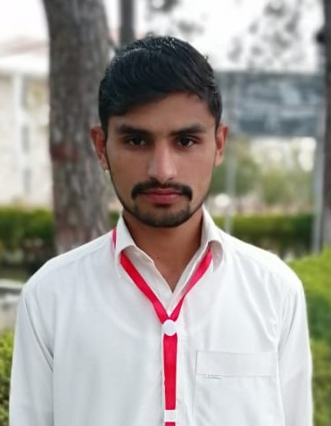

Date of Birth

30 march 1998

Father Name

Sikander Sher

Marital Status

Single

Nationality

Pakistani

CNIC #

13301-0533285-7

E-Mail Address

Nawaztariq248@gmail.com

Languages

* English
* Urdu
* Hindko
* Pushto
* Punjabi

Hobbies/Activities

* Research
* Recitation
* Net Surfing
* Reading Books